Floor 1

Entrance/exit

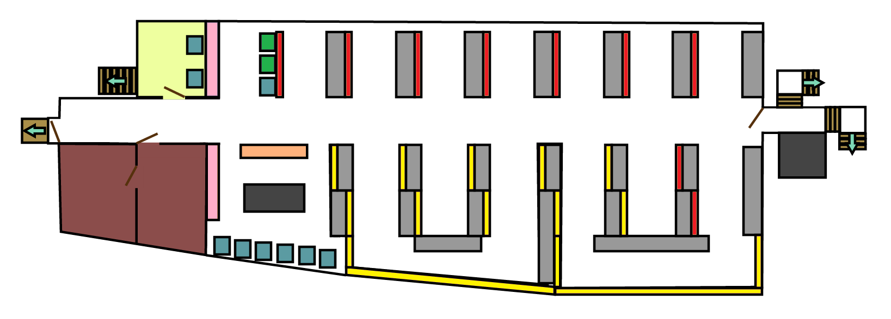

To the Old Library

Up to the Mezzanine

Down to Floor 2

Philosophy, Psychology, Religion (books A-B) Self-issue machines

History (books C-F) Desks

General interest (books and DVDs) Staff library office

Reference section (including past exam papers) Group study/quiet conversation

Computers

Floor 2

Mezzanine

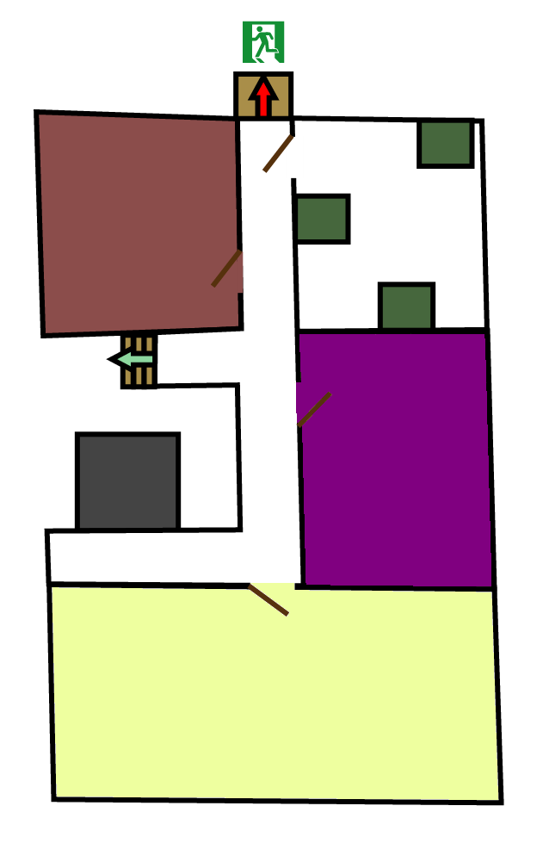

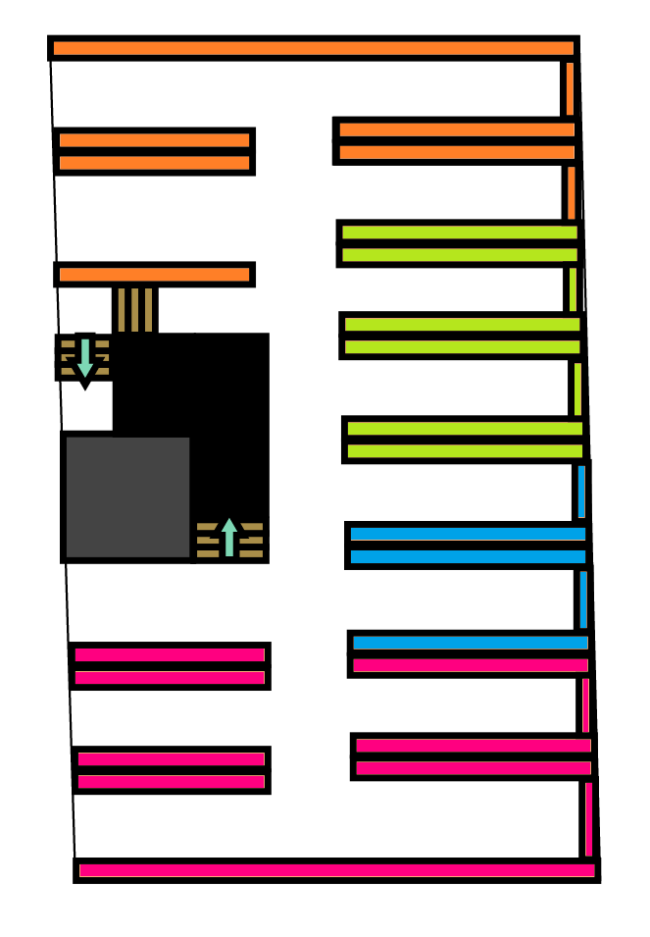

Down to Floor 3

Up to Floor 1

Down to Floor 1

Geography, Social Sciences (books G-H) Printers and scanner/photocopier

Politics, Law, Education (books J-L) Library IT helpdesk

Music, Art (books M-N) Staff library office

Languages (books P-PQ) Group study/quiet conversation

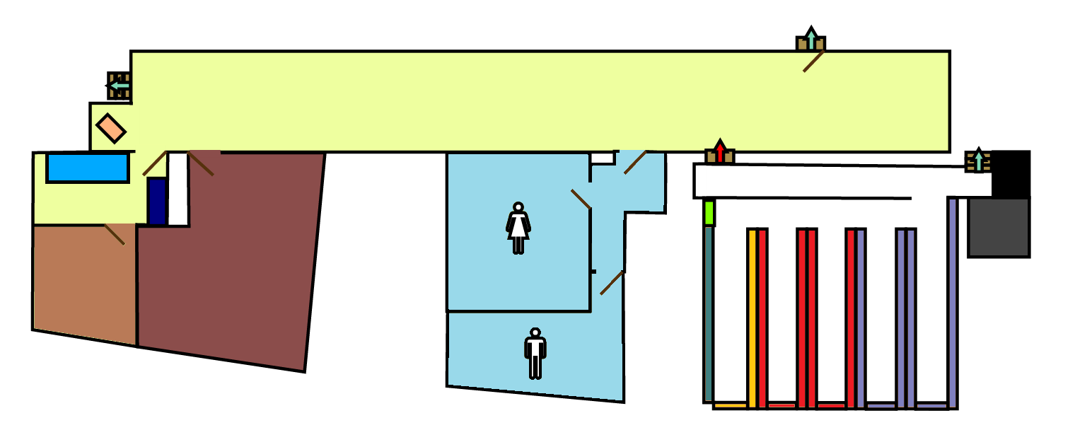

Toilets

Literature (books PQ-PT) Toilets Group study/quiet conversation

Maths, Sciences (books Q) Lost property locker Newspaper stand

Medicine, Agriculture, Technology (books R-T) Staff library office Water cooler/kettle

Military and Naval Science, Libraries and Skeleton Locker room  
Book Industry (books U-Z)

Up to Floor 2

Entrance/exit to Bath Court

Floor 3 and corridor

Fire escape only

To Floor 1